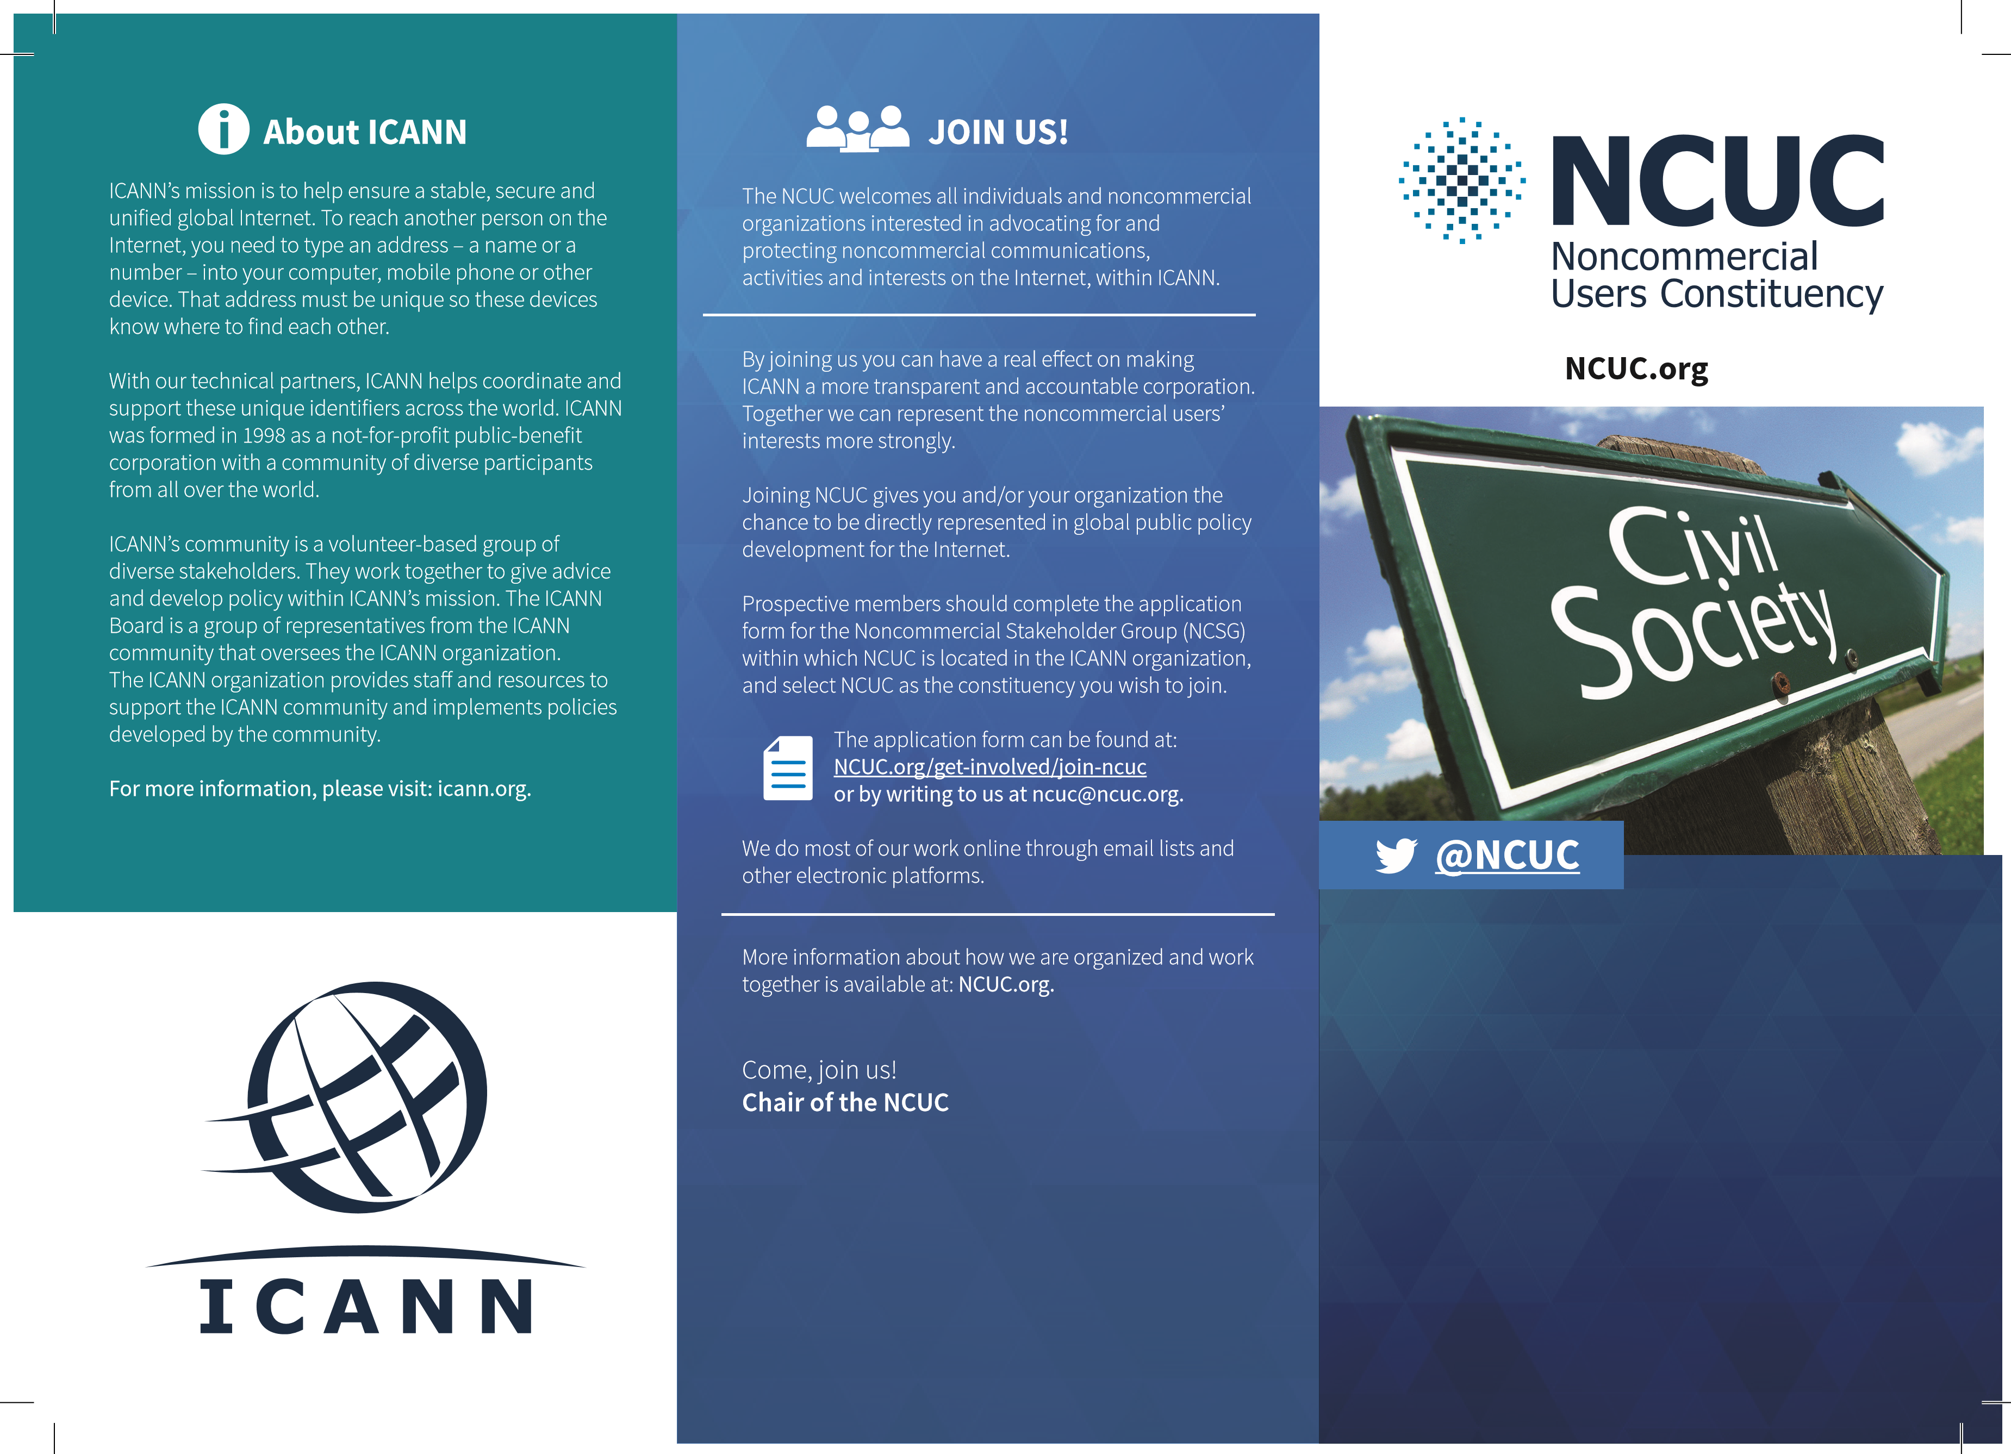
MAKE YOUR VOICE HEARD IN INTERNET GOVERNANCE

Who We Are
The Noncommercial Users Constituency (NCUC) is the home for civil society organizations and individuals in ICANN’s Generic Names Supporting Organization (GNSO). The GNSO is the place where different stakeholders are represented in ICANN and develop consensus policies for governing generic top level domain (gTLD) names like .com and .org.
The NCUC advocates positions on domain name-related policies that protect and support noncommercial communication and activity on the Internet. As a part of the GNSO’s Noncommercial Stakeholders Group (NCSG) we have real voting power in ICANN’s bottom-up, multistakeholder policymaking process, including the opportunity to help elect members of the GNSO Council and one member of the ICANN Board of Directors.
We have 758 members, comprised of 148 noncommercial organizations and 610 individuals (as of July 2022), from 100 countries across all five ICANN-recognized geographic regions.
Our members include individuals and non-profit organizations involved in civil liberties and human rights, Internet freedom, consumer protection, education, research, development and many other areas of public policy advocacy.

What We Do
Mobilize civil society actors to participate in ICANN, including its working groups and other processes
Send members to ICANN’s three meetings per year around the world, which are free of charge and open to all interested parties
Help elect (NCSG) representatives to the GNSO Council,
which coordinates the policy development process for gTLDs
Appoint representatives to ICANN’s Nominating Committee, which appoints members of the Board of Directors and other ICANN bodies
Develop and advocate policy positions
Collaborate and interact with other stakeholders in ICANN on matters of common concern, including businesses, governments and others
Organize conferences and events exploring global Internet governance issues

Noncommercial Uses and Users
We seek to ensure that commercial interests do not override the interests of non-profits and ordinary users

Diversity and Consumer Choice
We support a competitive domain name industry that offers Internet users innovation, quality and affordability

Human Rights
We promote an approach to domain name policy that is consistent with internationally recognized human rights

Freedom of Expression
We challenge efforts to abuse the core of the Internet by censoring expression and regulating content

Privacy
We oppose efforts to use domain registration records for indiscriminate surveillance

Access to Knowledge
We advocate for protection of the global public sphere against excessive intellectual property restrictions

Development
We work for policies that promote socio-economic growth and development in all areas of the world

Multilingual Internet
We want all cultures and linguistic groups represented in the domain name space

Denationalization
We supported transferring US government stewardship of the IANA to the global multistakeholder community

Global Internet Governance
We strive to make ICANN and other governance institutions accountable, fully open to multistakeholder participation and resistant to intergovernmental control

