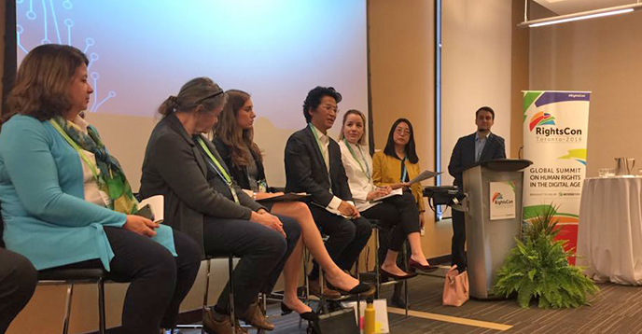

Multistakeholderism, GDPR, and NCUC in Toronto

RightsCon is among the world’s largest digital rights events, with over 2500 participants and 450 sessions across a range of thematic tracks. This year, I represented the NCUC at the event through the allocation of travel funds from the Community Regional Outreach Program (CROP).

The main impetus for the CROP application was to present a panel, which was developed by the NCUC, entitled: “Is Multistakeholder Internet Governance Advancing, Dying, or Evolving?”. The session proposal was developed by the NCUC, but in approving the panel, RightsCon requested that we merge with a similar session proposed by UNESCO, based on a recent report they published on multistakeholderism. We agreed to this, and I became co-moderator of the session, alongside Xianhong Hu of UNESCO.

There were two NCUC members on our panel: Matthew Shears and Anri van der Spuy. Jeremy Malcolm was originally supposed to be a panelist as well, but a flight delay forced him to cancel. However, we were extraordinarily lucky that Stephanie Perrin of the NCSG agreed to substitute in for him. The panel also included Katie Watson, from the Internet Society, Kyung-Sin Park, from Open Net Korea, and Susan Kawaguchi of the Business Constituency.

Sustained promotional efforts by both the NCUC and UNESCO meant that the session received a lot of interest in the run up to RightsCon, with over 117 people registered to attend. On the day of the panel the room was near capacity. Most of the attendees were from various civil society organizations, many of whom indicated that they were new to the subject. However, some attendees also represented governments or commercial interests in various branches of the Internet governance space.

From the beginning of the discussion, panelists pointed to a range of challenges facing multistakeholder Internet governance, including volunteer burnout, particularly as compounded by the complex nature of ICANN debates, and which often require not only a good understanding of the organization but also a technical and specialized thematic knowledge on issues like GDPR compliance. This leads to enormous pressure on the small group of participants who have these requisite skills. “I’m always happy to answer questions and offer guidance,” Stephanie noted, “the problem is, in many cases newcomers don’t know the questions to ask.” Participants also pointed to structural resource inequalities as a challenge, which can lead to under-representation from the Global South, as well as from marginalized communities. This challenge is often exacerbated by shrinking spaces for civil society in many countries.

Nonetheless, although panelists were stark about the challenges facing the system, the overall tone was positive, and affirmed the need to work to improve the multistakeholder system, rather than abandon it. “Challenges faced by multistakeholder participation is more a reflection of the challenges and uncertainties that are faced by Internet governance in general,” Matthew Shears said. He went on to note that, “the expertise of participants is more important than the number of people who are engaging in the processes. But, to avoid capture, it is important that all stakeholders can participate on an equal footing.”

Judging by the Q&A period, as well as informal discussions that followed the session, the message was very well received, and there was significant interest among the audience in the role that non-commercial voices play in the multistakeholder process. There was also substantial value to the conversation itself, and in bringing together experienced voices from across ICANN’s spectrum to discuss these issues.

In addition to that panel, while at RightsCon I hosted an NCUC booth in the Community Village, and delivered two lightning talks, on open contracting and on promoting transparency more generally. Although the lightning talks did not flow directly from my NCUC work, they are generally in line with much of my advocacy on behalf of the NCUC at ICANN, and the conversation around open contracting was particularly relevant to my work as the Rapporteur for the Workstream 2 Transparency subgroup, which is in the midst of debating this very issue with the Board. During the six hours that I manned the Community Village booth, alongside other NCUC volunteers, we received a steady stream of visitors, and passed out a good volume of NCUC swag (the webcam stickers were particularly popular), as well as providing explanations of how the multistakeholder process works and NCUC’s place in the ICANN ecosystem.

Unfortunately, my time at the Community Village booth overlapped with the NCSG’s session on ICANN and GDPR compliance. However, a recording is available online, and for those who have not yet listened to it, I would recommend you check it out. Particularly notable were the words of John Levine of the Stability and Security Advisory Committee, who began by stating although ICANN’s security people had a “long-running alliance of convenience with the trademark lawyers,” as a point of fact they didn’t like them at all, and opined that “the first week at ICANN, we made a mistake by letting the trademark lawyers into the room. And this whole intellectual property thing has been a huge distraction because it’s not really relevant to anything important that ICANN does.” The session also featured an energetic indictment of the previous WHOIS by Elliot Noss, the CEO of Tucows, as a system which is “rife with abuse” and should have been changed far earlier. The session is well worth listening to in its entirety.

Generally speaking, RightsCon is an excellent place for the NCUC to have a presence, and I am glad to have been able to attend as our representative. It was announced on the last day of the session that next year’s event will take place in Tunis – I look forward to seeing many of you there!

