

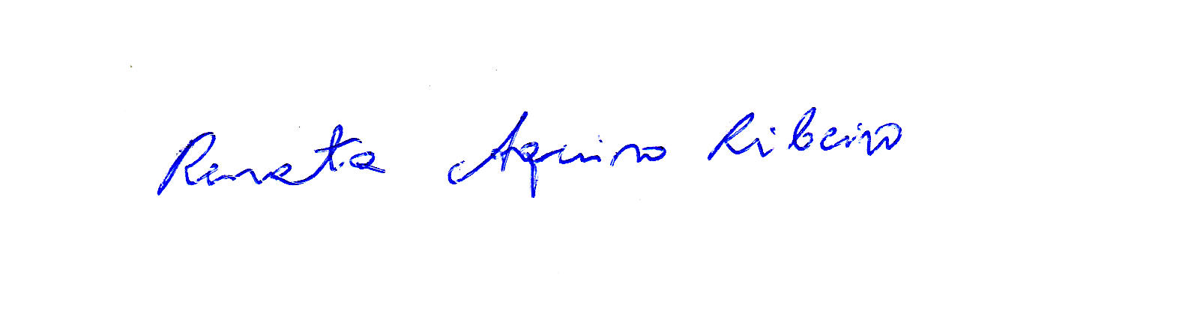

This certificate is awarded to

**Bruna Martins dos Santos**

Certificate of Attendance

 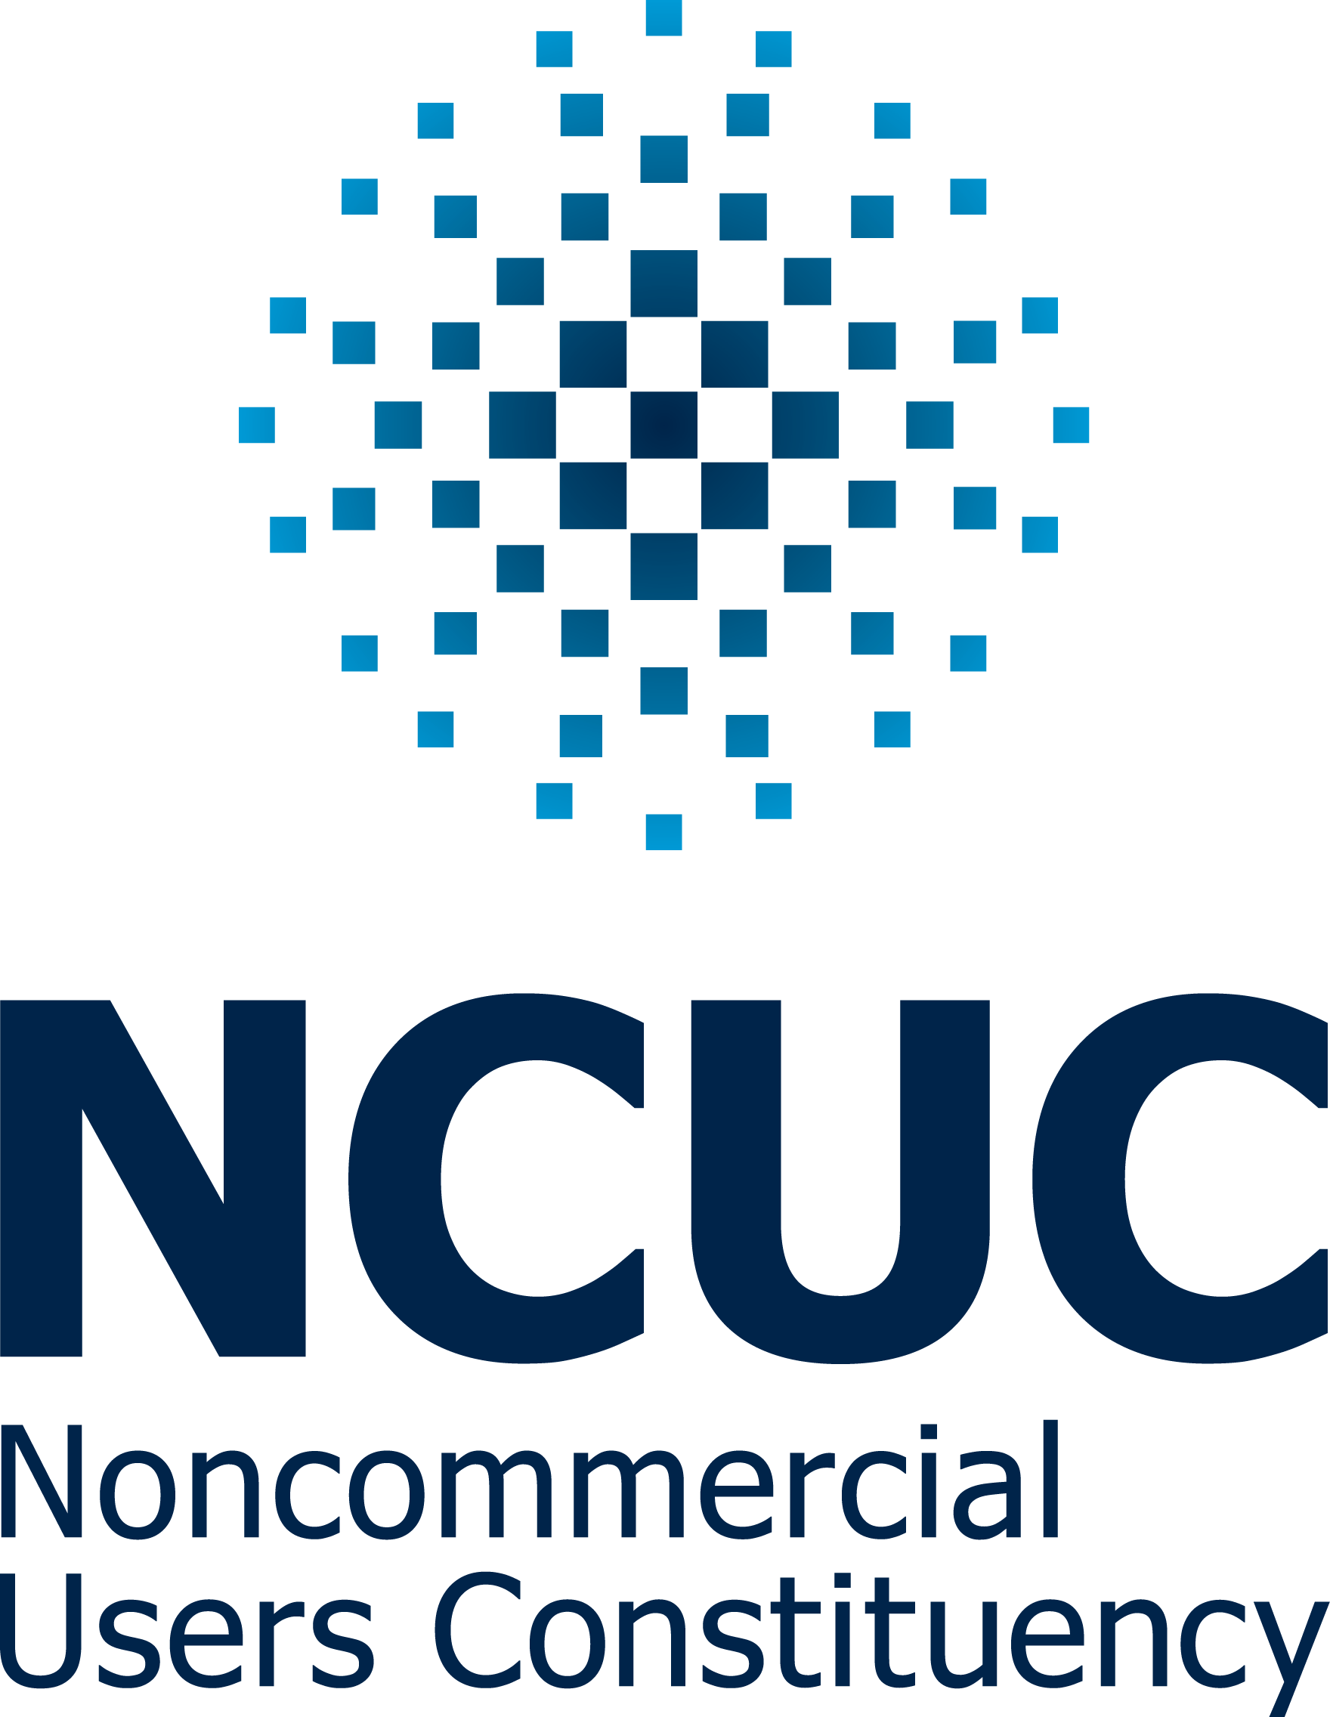

**David A. Olive** **Renata Aquino Ribeiro**   
*Senior Vice President Chair*

Policy Development Support NCUC

ICANN

for attending (remotely) the

**Writing for Policy and Public Comment Training**

February - March 2018

*Jointly organized by ICANN (Internet Corporation for Assigned Names and Numbers) and NCUC (Non-Commercial Users Constituency)*