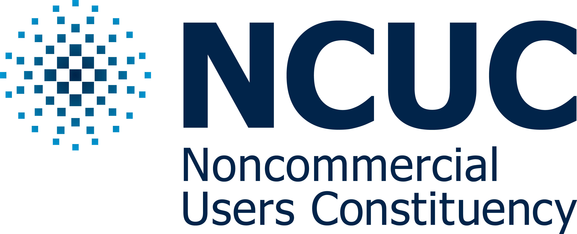

Dear ICANN Policy Staff, 28 May 2017

I am pleased to submit our revised NCUC Bylaws for your consideration and its referral to ICANN Board per procedures stipulated at: https://gnso.icann.org/en/about/stakeholders-constituencies/charter-amendment-process-28sep13-en.pdf.

The NCUC Bylaws was already voted on by the NCUC members in December 2016 and it was approved. We then received ICANN staff comments on the Bylaws. With the NCUC Executive Committee we considered all the comments and had several meetings to discuss them, you can find the recordings and transcripts of the meetings at this link: http://www.ncuc.org/governance/bylaws-meeting/.

You can find attached our answers to the comments and the changes that was deemed appropriate to be made by the NCUC EC.

I have also created a diff document in HTM format which shows the changes that was made to the Bylaws after the staff comment.

Thank you for your consideration and look forward to working with you to adopt the new Bylaws.

Best regards,

Farzaneh Badiei (Badii)

NCUC Chair

CC: NCUC Executive Committee Members

