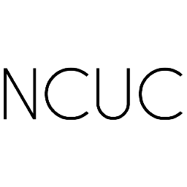


About ICANN

The Internet Corporation for Assigned Names and Numbers (ICANN) assigns domain names and manages some key technical aspects of the Internet’s underlying address book and central functions, including IP numbers and other unique technical identifiers.

ICANN develops policies related to how many top-level domains there will be, which ones will exist, to whom they will be assigned, and the regulations that apply to the entities that run them. Its policies are developed through a multi-stakeholder process.

ICANN has just completed a process of globalization, ending unilateral U.S. government oversight. ICANN is now accountable to the global community under rules created by the Internet community.

ICANN has offices and engagement centers in different parts of the world. Information on ICANN’s

organization, governance, procedures, and range of activities is all available at https://www.icann.org.

@ ICANN

Noncommercial Users Constituency www.ncuc.org

Join Us!

The NCUC welcomes all individuals and noncommercial organizations interested in advocating for and protecting noncommercial communications, activities and interests on the Internet, within ICANN.

By joining us you can have a real effect on making ICANN a more transparent and accountable corporation. Together we can represent the noncommercial users’ interests more strongly.

Joining NCUC gives you and/or your organization the chance to be directly represented in global public policy development for the Internet.

Prospective members should complete the application form for the Noncommercial Stakeholder Group (NCSG) within which NCUC is located in the ICANN organization, and select NCUC as the constituency you wish to join.

The application form can be found at:

http://ncuc.org/page/become-a-member

or by writing to us at ncuc@ncuc.org.

We do most of our work online through email lists and other electronic platforms.

More information about how we are organized and work together is available at: www.ncuc.org.

Come, join us!

Farzaneh Badii, Chair of the NCUC

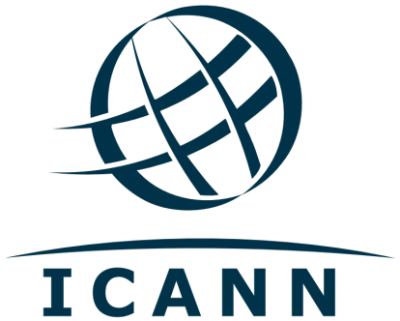
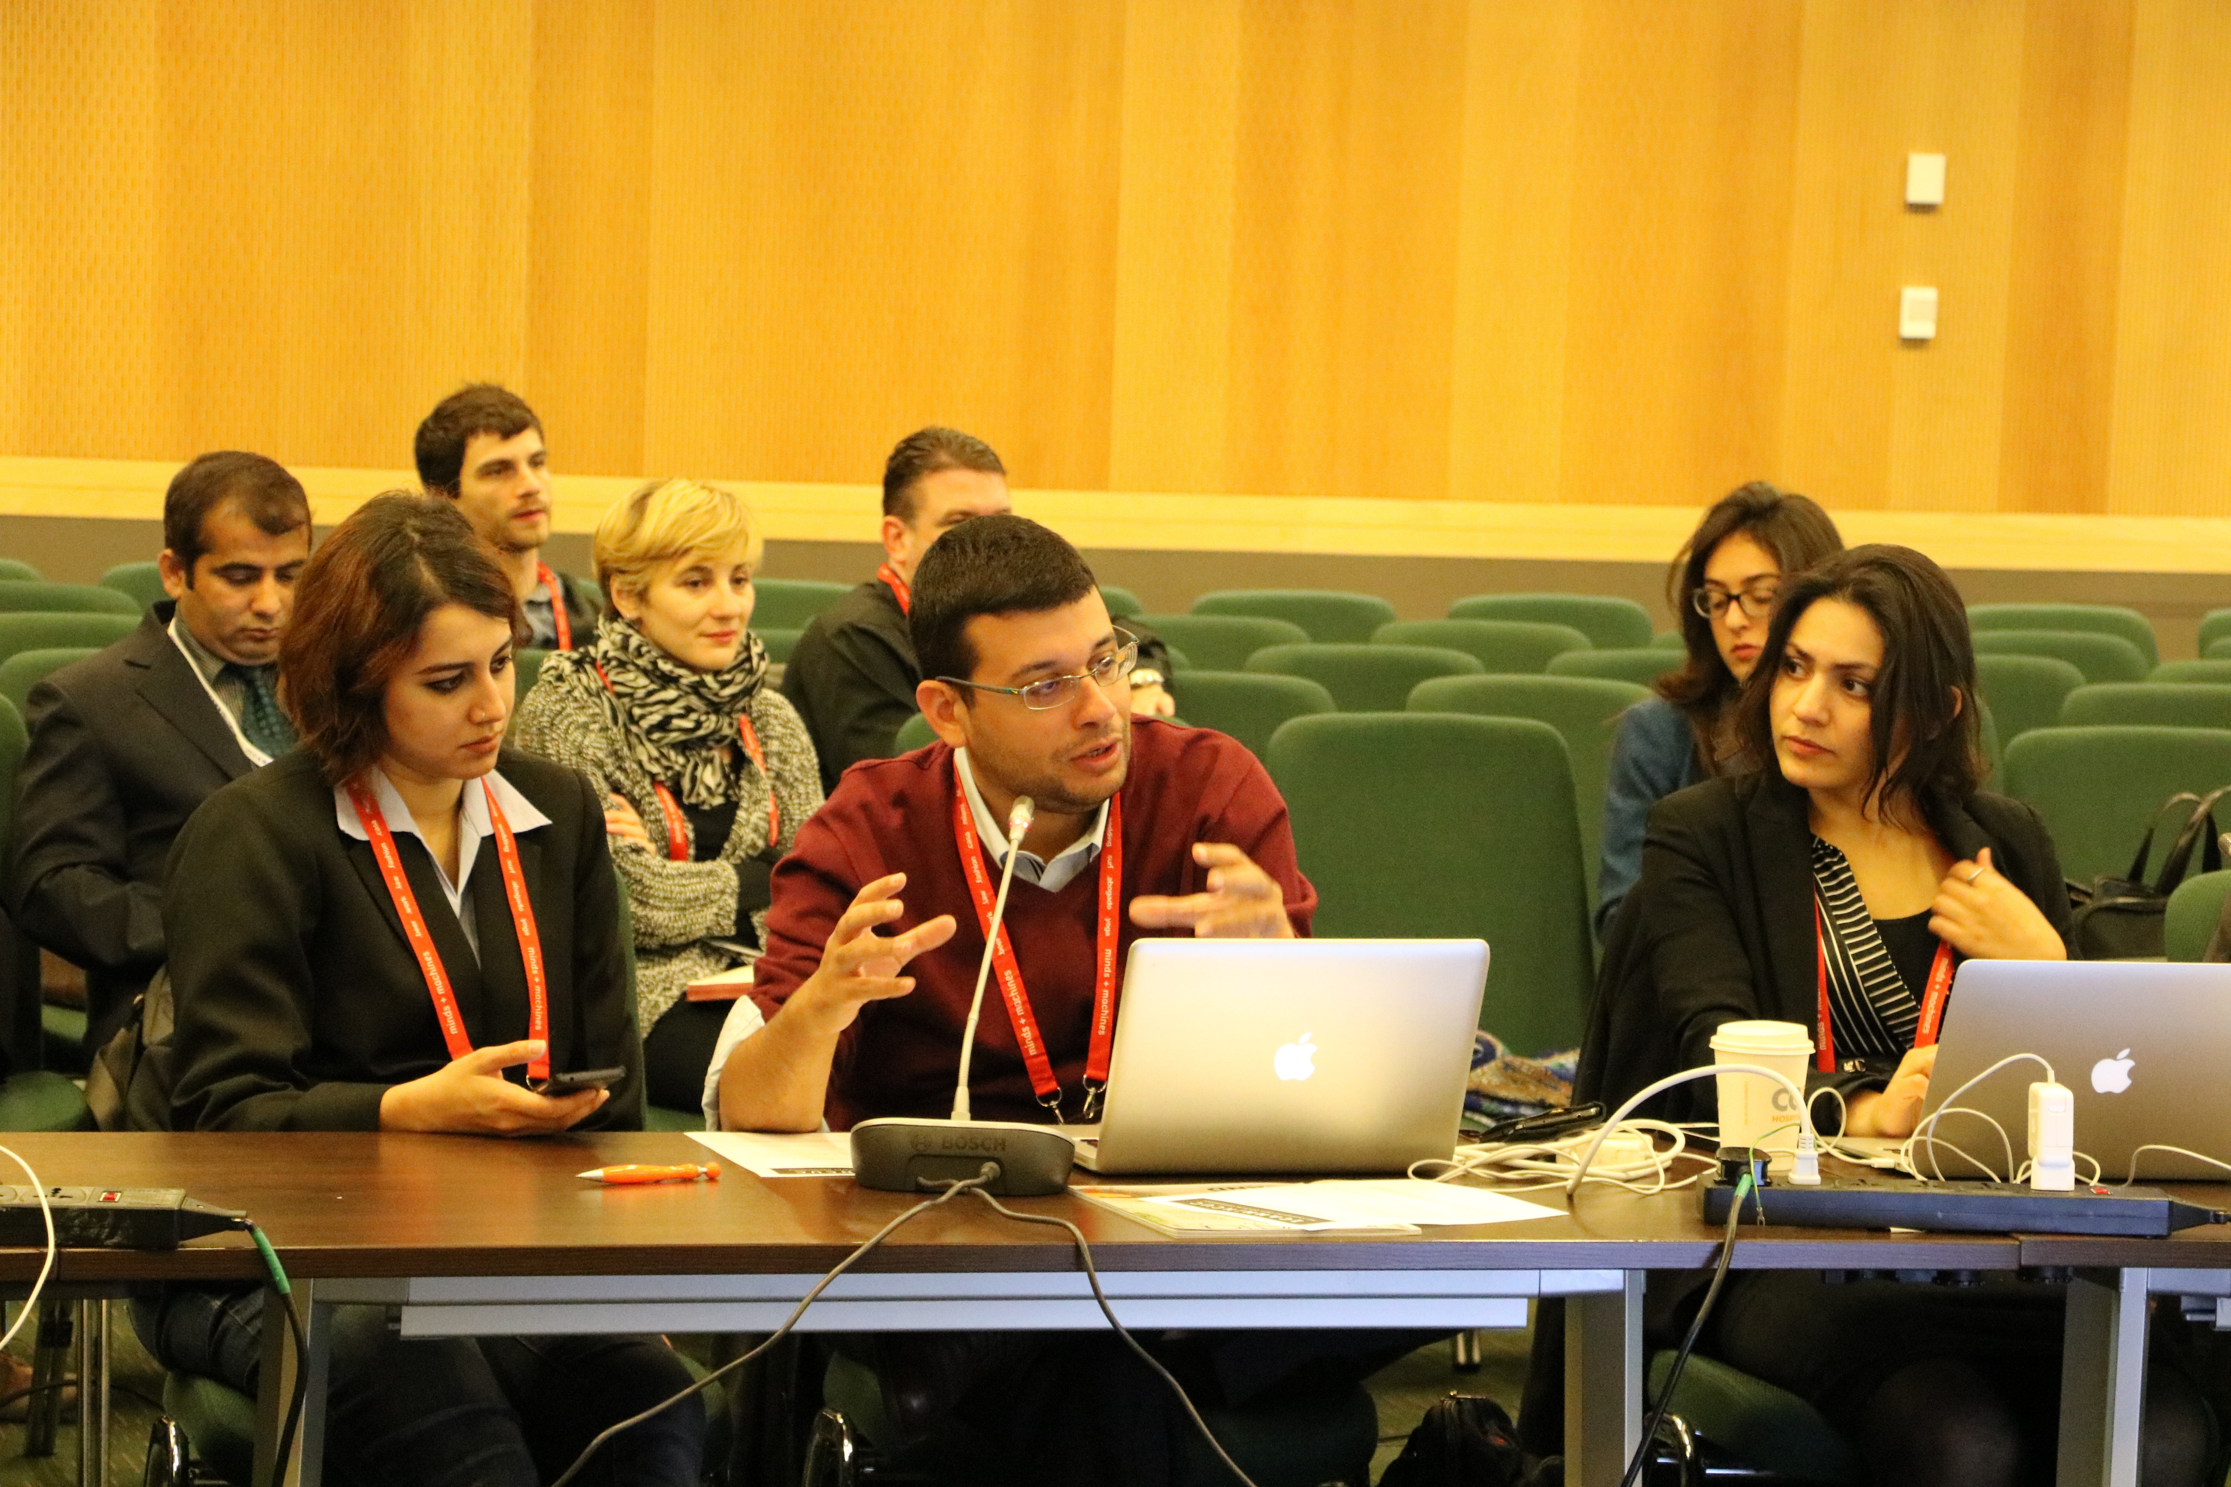

Make Your Voice Heard in Internet Governance

Who We Are

The Noncommercial Users Constituency (NCUC) is the home for civil society organizations and individuals in ICANN’s Generic Names Supporting Organization (GNSO). The GNSO is the place where different stakeholders are represented in ICANN and develop consensus policies for governing generic top level domain (gTLD) names like .com and .org.

The NCUC advocates positions on domain name-related policies that protect and support noncommercial communication and activity on the Internet. As a part of the GNSO’s Noncommercial Stakeholders Group (NCSG) we have real voting power in ICANN's bottom up, multi-stakeholder policymaking process, includig the opportunity to help elect members of the GNSO Council and one member of the ICANN Board of Directors.

We have 462 members from 107 countries and all five ICANN-recognized geographic regions, including 118 noncommercial organizations and 420 individuals a (as of January 2017).

Our members include individuals and non-profit organizations involved in civil liberties and human rights, Internet freedom, consumer protection, education, research, development, and many other areas of public policy advocacy.

What We Do

Mobilize civil society actors to participate in ICANN, including its working groups and other processes

Send members to ICANN’s three meetings per year around the world, which are free of charge and open to all interested parties

Help elect (NCSG) representatives to the GNSO Council, which coordinates the policy development process for gTLDs

Appoint representatives to ICANN’s Nominating Committee, which appoints members of the Board of Directors and other ICANN bodies

Develop and advocate policy positions

Collaborate and interact with other stakeholders in ICANN on matters of common concern, including businesses, governments, and others
Organize conferences and events exploring global Internet governance issues

Noncommercial Uses and Users

We seek to ensure that commercial interests do not override the interests of non-profits and ordinary users

Diversity and Consumer Choice

We support a competitive domain name industry that offers Internet users innovation, quality, and affordability

Human Rights

We promote an approach to domain name policy that is consistent with internationally recognized human rights

Freedom of Expression

We challenge efforts to abuse the core of the Internet by censoring expression and regulating content

Privacy

We oppose efforts to use domain registration records for indiscriminate surveillance

Access to Knowledge

We advocate for protection of the global public sphere against excessive intellectual property restrictions

Development

We work for policies that promote socio-economic growth and development in all areas of the world

Multilingual Internet

We want all cultures and linguistic groups represented in the domain name space

Denationalization

We supportted transferring US government stewardship of the IANA to the global multistakeholder community

Global Internet Governance

We strive to make ICANN and other governance institutions accountable, fully open to multistakeholder participation, and resistant to intergovernmental control

