Noncommercial Users Constituency

The Internet Corporation for Assigned Names and Numbers’ (ICANN) Noncommercial Users Constituency (NCUC) advocates positions on domain name-related policies that protect and support noncommercial communication and activity on the Internet. NCUC members are involved in civil liberties and human rights, Internet freedom, consumer protection, education, research, development, and many other areas of public policy advocacy, both within ICANN and other Internet governance and Internet policy spaces.

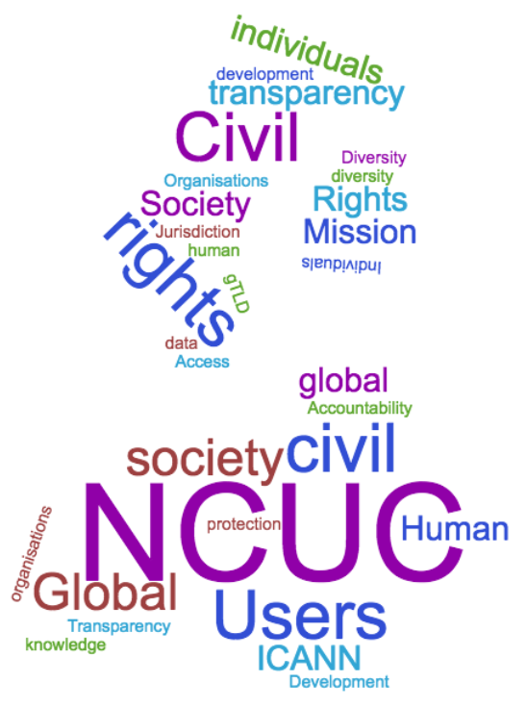
Since 1999, the NCUC has championed issues such as freedom of expression, privacy, and human rights. Today more than 110 organisations and over 420 individuals from 115 different countries support NCUC policy development. The NCUC is the leading representative of civil society in ICANN’s multistakeholder model. Civil society will find much of NCUC’s work relevant to their missions and expertise – we need your help and support to make civil society’s voice even stronger, more diverse, and more vibrant within ICANN.

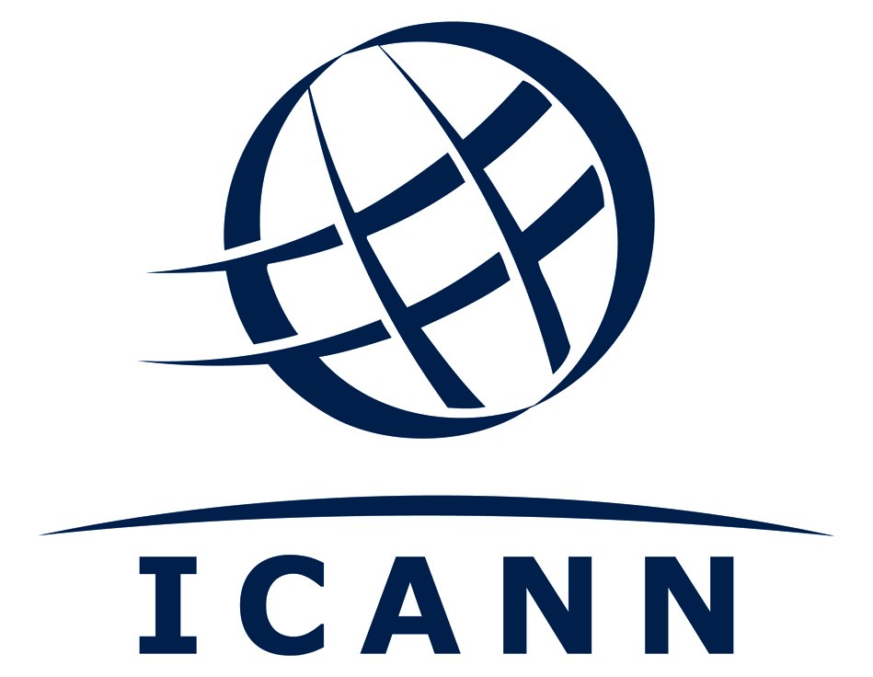
NCUC and the IANA stewardship transition:

The multistakeholder

model at work

The United States’ particular role in the domain name system (DNS) and critical Internet resources had been a point of contention for more than a decade. When the Internet community was asked to develop a proposal that would transition the Internet Assigned Numbers Authority (IANA) functions away from U.S. government control, this was an important opportunity for Internet policymakers and those interested in Internet policy to get directly involved in this process. The NCUC continues to be at the forefront of these discussions.

The NCUC developed and shepherded non-commercial responses to transition proposals, and is leading ongoing work, such as with accountability, transparency, and human rights-related advocacy.

ICANN and human rights

NCUC members have been working on human rights issues for many years. A recent and visible success has been in the process of the IANA stewardship transition, during the work of the Cross-Community Working Group (CCWG) on Enhancing ICANN Accountability (CCWG-Accountability).

The NCUC was able to mobilise its members and experts from the multistakeholder community to push for the inclusion of the human rights provisions in ICANN’s bylaws. At first, these proposals were criticised as premature by the ICANN Board and some parts of the ICANN community. Just a month later, with in the final version of the CCWG-Accountability’s recommendations, however, it was clear that the NCUC helped build consensus on new bylaws language adopting a human rights core value. We are now developing a framework of interpretation that will operationalise this commitment.

What we need now is more contributions from civil society experts to continue this work.

Access to knowledge

and trademarks

Domain names are the places in which we share our expression. Our websites, email lists, discussion forums, and emails carry our most important thoughts and ideas. No one should be able to remove a domain name without due process – without proof of bad faith and/or wrongdoing in the appropriate way.
Since the earliest days of ICANN, the NCUC has focused on the balance between freedom of expression and trademark rights. With regards to domain names, this manifests itself, for example, when people want to register what somebody else would consider to be their trademark in a domain name. The domain name might be used in ways that have nothing to do with the trademark, yet trademark owners want to protect their brand. The NCUC advocates for the protection of the global public sphere against excessive intellectual property restrictions. Never before have trademark owners been allowed to “own” the words of their brands, particularly when those words are also common names, generic words, or dictionary words. Nevertheless, this idea is continually being introduced into the DNS. At each opportunity, the NCUC leads the fight for the rights of all to use basic words, names, and concepts. We played a key role in drafting the balances that protect noncommercial rights in domain name dispute policies, including ICANN’s Uniform Dispute Resolution Policy (UDRP) for all generic top-level domains (gTLDs) and Uniform Rapid Suspension Policy (URS) for new gTLDs. Similarly, we oppose the efforts of some national governments to take control of all geographical names. The NCUC believes that these uses represent infringements on freedom of expression.
The NCUC fought for the more traditional balance of trademark law and fair use, free expression, and due process. We have taken that balance to the technologists as well as multistakeholder communities that are creating these Internet infrastructure rules and won many of the issues we fought for. Domain name registrants past are more protected because of our work.

Freedom of expression is under threat, and the NCUC challenges efforts to abuse the DNS and core of the Internet by censoring expression and regulating content. This is an important work area of growing concern.

Privacy issues at ICANN

Privacy has been under threat since ICANN was created, and the NCUC has constantly fought for domain registrants’ rights. So, what are the privacy issues at ICANN?

Years ago, when the Internet was a closed and trusted network, a directory was created with the names, addresses, phone numbers, and email addresses of domain name registrants, mostly researchers who listed organizational data. Called the WHOIS, this directory was specified as a requirement at the inception of ICANN, and has grown into a public directory of all who register domains. Now it carries the names, phone numbers, and physical addresses of people and organizations throughout the world, including political, ethnic, religious, and sexual minorities, among other groups. The NCUC believes that individuals and organizations are entitled to privacy in their domain name registrations, and the right to due process before their identifying data is disclosed.

Anyone who registers a name is required to provide full and accurate data so that registrars can fulfill their obligations to ICANN under the Registrars Accreditation Agreement. That agreement has four problematic requirements from a data protection perspective. The first is that more data must be collected than is necessary to support ICANN’s limited role in the ecosystem. Second, a broad range of data must be published in the public WHOIS directory, which the registrars and registries are obliged to support. Third, registrars are obliged to retain data about their transactions with registrants, including financial details, emails, and other administrative data, for a period of 6 months after the last transaction with that customer. The fourth problematic requirement is the obligation to escrow data with ICANN’s escrow agent in the U.S. All of these requirements are potential infringements of data protection law.

The NCUC has fought to restrict these abuses of registrant rights against misguided policy ideas and the data demands of stakeholders such as intellectual property interests and law enforcement agencies. The NCUC and partners from global civil society have been successful in ensuring Privacy Proxy services will continue to be offered by registrars and other parties, ensuring we can continue to use a third party to shield our data. If privacy issues are your passion, the NCUC needs your support in this longest running of all civil society battles within ICANN.

Further enhancing accountability and ensuring transparency

During the IANA stewardship transition and work on enhancing ICANN accountability, the NCUC was prominent in the development of recommendations for respecting the public interest, enhanced transparency, and ensuring consideration for human rights, among other issues. The transition is complete, but work continues in Work Stream 2, where topics that were committed to in the transition will continue to be developed. Civil society still has a lot to do in ensuring effective implementation. These issues include consideration of ICANN’s jurisdiction, enhancing ICANN’s transparency, completing commitments to human rights, improving diversity, increasing the accountability of ICANN’s volunteer community, increasing staff accountability, reviewing the role of the ombudsman, and independent appeal. The NCUC is very active in all of these discussions. These are stand-alone issues that any one interested can contribute to, all topics where civil society has expertise.

Jurisdiction: NCUC members are leading the multistakeholder working group on the impact of ICANN’s jurisdiction of its accountability and policymaking processes. As the coordinator and policymaker for the global DNS, ICANN needs to be global in scope, yet to be accountable, it needs to be incorporated under some government’s law. There is an ongoing political and legal tension between ICANN’s global scope and its legal jurisdiction in California. This working group is exploring that problem.

Transparency: Improving transparency is a major focus for the NCUC in ICANN’s ongoing reform processes. There are broad benefits that flow from robust transparency, such as combatting the potential for capture and mismanagement, and facilitating broad oversight over decision-making. ICANN’s unique multistakeholder structure, where decisions are the result of broad consultative processes, requires robust transparency. ICANN’s decision-making is only as strong as the level of understanding that the community has over the issues that ICANN faces.

Two rapporteurs, drawn from civil society and the commercial sector, have led a robust process of soliciting feedback from human rights advocates, business interests, the technical community, and other stakeholders, in order to develop a set of recommendations for making ICANN a global leader in transparent governance and decision-making. An issue the NCUC ensured was included in the transition recommendations is to reform ICANN’s Documentary Information Disclosure Policy (DIDP), which has been criticised as often not responding to requests in a fair manner, with too many redactions. The NCUC is working to strengthen the culture of transparency at ICANN.

.
.
.
.
.
.
.
.
.
.
.
.
.
.
.
.
.
.
.
.
.

Join Us!

The NCUC welcomes all individuals and non-commercial organisations interested in advocating for and protecting non-commercial communications, activities, and interests on the Internet. We need your expertise and knowledge! By joining the NCUC, you can have a real effect on making ICANN a more transparent and accountable organisation. Join us and promote non-commercial interests within ICANN and the larger Internet governance ecosystem!

Website: http://www.ncuc.org
Contact: ncuc@ncuc.org
Join: http://ncuc.org/join

