Key words, Impressions
As Aicha phrased it: “ key words that NCUC aim to represent, abide by or support.” Just add them wherever you want, I will create a word cloud afterwards to see what was mentioned often

Openness,Grass-roots, freedom of expression, Internet, collaborative (chain?),
interconnected, conversation.
policy professionals, domain name natives, volunteer fanatics, collaboration creators, multistakeholder(itus), believers in bottom-up, deliberative dialogue, ICANN enthusiasts .
Community,Voice for individual users, Place for Academic enthusiasts

Activism, intellectual work, politics, world citizen, writings

Suggestions on attributes of the future logo
something that connect, augment and empower and enfasizes
diversity, trough shapes, graphics, colors

Have in mind diversity

Very important to remember logo should also work for printed B & W material which may occasionally be needed

Concrete Logo suggestions
One Line for one suggestions, if possible add links to images or include images directly.
Tulip shaped logo. Tulip is the symbol of passion. The passion can be for a cause.
Variations on one of those:
http://content.sportslogos.net/news/2014/02/Bucs-Logo.png

http://www.clipartkid.com/images/120/notre-dame-fighting-irish-logos-logotipos-gratuitos-clipartlogo-com-YGbhWf-clipart.png

https://stvrsnbrgr.files.wordpress.com/2014/06/tiananmen-bw.png
http://static.tvtropes.org/pmwiki/pub/images/raspberry_1325.JPG
giraffe
zebra
donkey
Okapi
Ant - http://beehivecollective.org/
dung beetle
thistle
stylized version of Delacroix’s liberty leading the people? We could change the French flag to an ICANN logo?http://www.artble.com/imgs/b/d/4/134968/778457.jpg
play on the Apple logo by taking a bite out of the ICANN globe
Ganesh, the Hindu god who is the remover of obstacles.
Honeycomb with the letters N C U C embedded in the hexagons

For example something like this image.

Source: https://www.freevector.com/uploads/vector/preview/16068/FreeVector-Honeycomb-Graphics.jpg

N C U C letters with some (may be ICANN's) globe in the background or some kinda Dawn/Light in the background:
Like this:

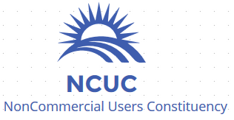
This one is not bad (MM)

some suggested that the globe should probably be turned away from north america

This looks elegant. I suggested to use the globe from ICANN’s logo instead of this globe.

common flag made of the different flags representing members of NCUC
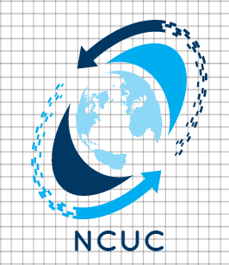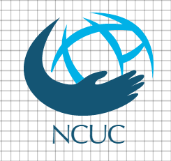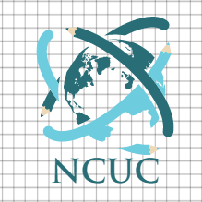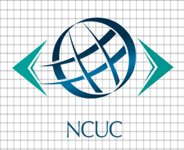
Some ideas.
Thinking of community. I am no designer :)

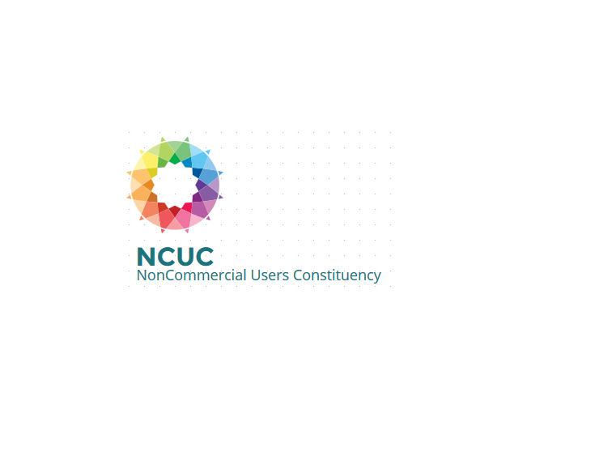

IDEA: NCUC as a building supported by multicultural individuals, Academy
