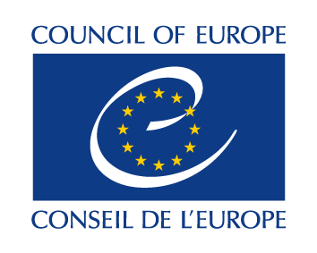 |  | 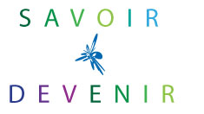

Internet Governance Forum
SAVE THE DATE

DISRUPTIVE DIGITAL LITERACIES IN THE ERA OF DATA GOVERNANCE:
ADDRESSING ‘GENERATION Z’, WITH AND BEYOND EDUCATION
.
Sunday 17 December 2017, 14:00-17:00, ROOM 4
Pre-Event organized by the Council of Europe in association with Savoir*Devenir
CICG Geneva - Centre International de Conférences, Rue de Varembé 17, Geneva

Presentation

This event examines the future of digital literacies and education with regard to data flows and their impact. Data governance should indeed be shared with governments, institutions and structures. So how do we manage the disruption caused by data flows? What digital literacy do we want? What education do we need to prepare the next generation of learners, workers and citizens? What policies for policy-makers and public sector professionals? How can the private sector and civil society contribute, support and benefit?

Programme :( https://igf2017.intgovforum.org/)
- Opening

Opening remarks: Divina Frau-Meigs, Professeur, Sorbonne Nouvelle, President Savoir*Devenir

Opening Statements: Frank La Rue, Assistant Director-General Communication/Information, UNESCO, Villano Qiriazi, Head of Education Policy Division, Council of Europe

Tour de table on insights, lessons learned and perspectives
- Harnessing Big Data for Education: e-strategies for all
- How much control over data? What data portability? Critical Thinking vs Magic Thinking? What platform and media responsibility?
Session moderated by Jasmina Byrne, Senior research, UNICEF Innocenti
Open discussion with input from:
. Carl Gahnberg, Global public Policy, ISOC
. Pascale Serrier, Commission nationale de l'informatique et des libertés, CNIL (TBC)
. Jelena Mocevic, European Heritage Days

Youth Respondent: Ruxa Pandea, No Hate Speech and Cooperation, Council of Europe

- Enabling young people in formal and informal education : competences and values
How are young people prepared? Preparedness for e-citizenship?
Session moderated by Villano Qiriazi, Head of Education Policy Division, Council of Europe

Open discussion with input from:
. Larry Magid, Founder Connect Safely and CBS
. Elisabeth Milovidov, Consultant and Coach on Digital Parenting
. Janice Richardson, Senior consultant on children’s rights, education and awareness (Insight)
. Stephen Wyber, Policy and Research Officer, IFLA (Intl Fed. of Library Associations & Institutions)
. Sophie Valais, Analyst, European Audiovisual observatory

Youth Respondent: Anca Sandescu, Human rights education and minority rights, trainer on hate speech related issues

- Skilling citizens and working adults : Digital, lifelong, training and beyond
How are citizens skilled and how are these skills updated? What needs, values and competences should be included? How is their agency solicited? How is the capacity to interact/contribute? What level of citizen control/ownership is available to them? How can governments and private sector enable and be enabled?

Session co-moderated by Janice Richardson, Senior consultant on children’s rights, education and awareness (Insight), and Elisabeth Milovidov, Consultant and Coach on Digital Parenting

Open discussion with input from:

. Marilia Maciel, Digital Policy Senior Researcher, DiploFoundation
. Mathieu Muselet, Coordinator of Open Badge, la Ligue de l’Enseignement
. Yves Mathieu, Co-founder, Missions Publiques

Youth Respondent: Menno Ettema, No Hate Speech and Cooperation, Council of Europe

- Mapping of disruptive digital literacies – towards global citizenship consultation and dialogue

Closing remarks: Divina Frau Meigs, Professeur, Sorbonne Nouvelle, President Savoir*Devenir.

CONTACTS :
Council of Europe  Lee Hibbard - Lee.HIBBARD@coe.int | Savoir*Devenir  Divina Frau-Meigs – divina@savoirdevenir.net  Pascale Garreau – pascale@savoirdevenir.net

To keep up with us : http://sched.co/CR5k

