Community Support at ICANN
Community Consultation Process to Review Current ICANN Community Travel Support Guidelines

Background and Rationale

The ICANN organization supports the work of the ICANN volunteer community to ensure the Internet remains interoperable, resilient and secure. Volunteer participation comes in many forms—through working groups, attending ICANN Public Meetings, joining a stakeholder community. The ICANN organization is committed to providing the necessary resources to invest in a sustainable community. This includes capacity development, administrative and travel support, outreach and engagement.

Supporting diverse, global participation in ICANN’s policy-making work is a key part of the ICANN mission. Demands are growing over time, driven by many factors including but not limited to increasing cross-community work, robust policy development and implementation, growth in working groups, and expansion of reviews.

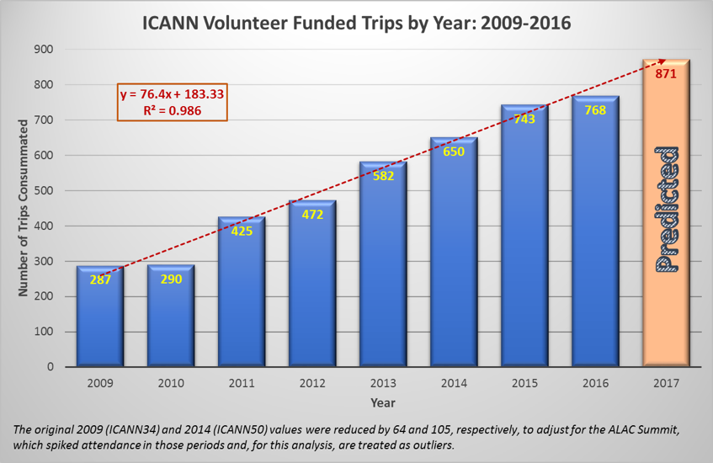

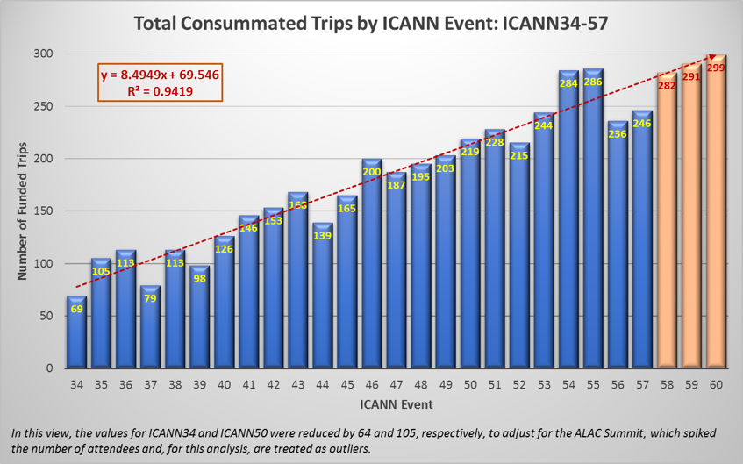
As part of delivering these contributions, the ICANN organization recognizes the significant value provided to its mission and work by community leaders and contributing participants at ICANN Public Meetings. Likewise, the ICANN organization recognizes that individual community requests to increase permanent travel support levels at ICANN Public Meetings are important and strategic, requiring consideration as part of the overall Operating Plan and Budget.

As the community grows, we need to examine whether the current ICANN Community Travel Support Guidelines are still fit for purpose. For example, over the past few years, several communities have experimented with increased levels of funding through the Additional Budget Request process. In a number of those cases, increased travel support was later incorporated into the Operating Plan and Budget.

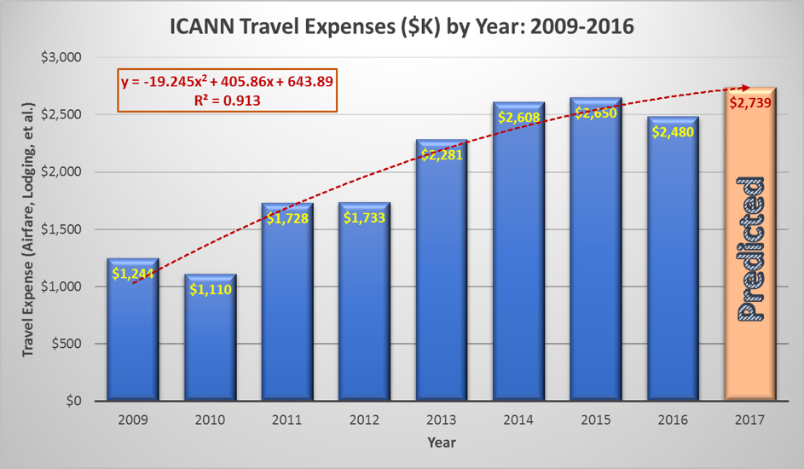

These experiences and growing demand have revealed that the guidelines for community travel support are no longer comprehensive and need updating. The ICANN Community Travel Support Guidelines were last updated in 2013 for fiscal year 2014 and published on the Community Travel Support page. In the spirit of greater accountability and transparency, the ICANN organization seeks to begin strategic conversations with the community about travel support and community resources.

The long-term sustainability of community travel support requires strategic consideration by the entire community. As part of these strategic conversations, the ICANN organization is initiating a community consultation to examine and assess the best approach to review the purpose, value, and resources needed to continue supporting the community in its deliberations at ICANN Public Meetings. Through this process, the ICANN organization will collect feedback and views from the Supporting Organizations and Advisory Committees and their constituent groups. This information will guide resource planning for future Operating Plans and Budgets.

Proposed Consultation Plan and Timeline

As a first step, Patrick Jones and Carlos Reyes from the Global Stakeholder Engagement and Policy Development Support teams, respectively, have drafted a questionnaire to begin the community consultation. Patrick and Carlos are available to speak with community groups about the current ICANN Community Travel consultation and the questionnaire. This questionnaire explores community travel support at a high-level.

The answers to these questions will inform more targeted engagements in the near future. Potential engagements may include a focus group at ICANN60 and a public comment proceeding on the current ICANN Community Travel Support Guidelines. Patrick and Carlos will build on feedback from these engagements and the questionnaire to revise the current ICANN Community Travel Support Guidelines, consulting with relevant ICANN organization departments and community groups as necessary. The goal is to have draft guidelines by the end of 2017.

Patrick and Carlos will then share the draft guidelines in January 2018 with all community groups for initial feedback. Patrick and Carlos will capture this initial input and update the draft guidelines as necessary. The draft guidelines will then be posted for public comment in February 2018 following the standard 40-day (minimum) process.

Once all feedback is received from the community groups and the public comment proceeding, Patrick and Carlos will prepare the final draft of the new ICANN Community Travel Support Guidelines in coordination with the relevant ICANN organization departments and recommend a target implementation date. Patrick and Carlos will brief all community groups on the updated ICANN Community Travel Support Guidelines and the target implementation date through a webinar and at ICANN61 in March 2018 if requested.

After ICANN61, Patrick and Carlos will work with the relevant ICANN organization department to prepare for implementation of the updated ICANN Community Travel Support Guidelines.

Questionnaire

- What guidelines does your group have for supported travelers? How do these differ from the ICANN Community Travel Support Guidelines?

- What aspect of the current ICANN Community Travel Support Guidelines work well for your group?

- What specific area of the ICANN Community Travel Support Guidelines affect your group the most?

- What area might be added to the ICANN Community Travel Support Guidelines to provide additional support to your group?

- How does your group allocate its community travel support slots? How are members prioritized? How are newcomers to ICANN considered?

- What, if any, educational and informational activities does your group conduct to inform participants of ICANN community resources?

- What are actionable and measurable expectations your group or leadership has for members who receive travel support? Are there follow-up reporting requirements for members who attend ICANN Public Meetings and/or receive Community Regional Outreach Program (CROP) funding?

- Instead of reimbursement for travel-related expenses, would your members prefer to receive a stipend or per diem from the ICANN organization?

- Are there categories of travel and events that you are not presently able to support?

- How does your group plan for upcoming events? What is your planning cycle for deciding on whether ICANN community or organization resources might be used?

You are welcome to append any general comments on the community resource consultation.

